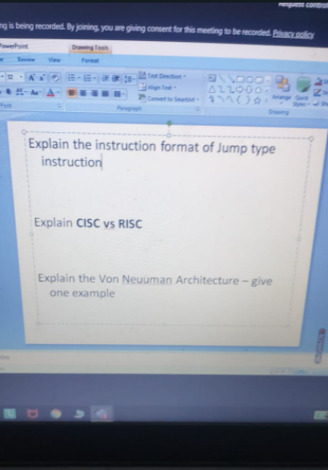

1. Explain instruction format of jump type instruction

* Unconditional branch
* J 10000 is represented as 2 6-bits 2500 26 bits

1. CISC Vs RISC:

* **RISC** stands for Reduced Instruction Set Computer.
* **CISC** stands for Complex Instruction Set Computer.
* One of the major differences between RISC and CISC is that RISC emphasizes efficiency in cycles per instruction and CISC emphasizes efficiency in instructions per program.
* <https://www.elprocus.com/difference-between-risc-and-cisc-architecture/>

1. Von Neuunamm :

* Von Neumann architecture is based on the stored-program computer concept, where instruction data and program data are stored in the same memory.
* <https://www.javatpoint.com/von-neumann-model>